Sanjay Dookhoo

sanjaydookhoo@msn.com

Project Implementation document

Contents

Architectural Design 2

Class Diagram 3

Entity Relationship 4

Sequence Diagram 5

Description of Technology Used 7

# Architectural Design

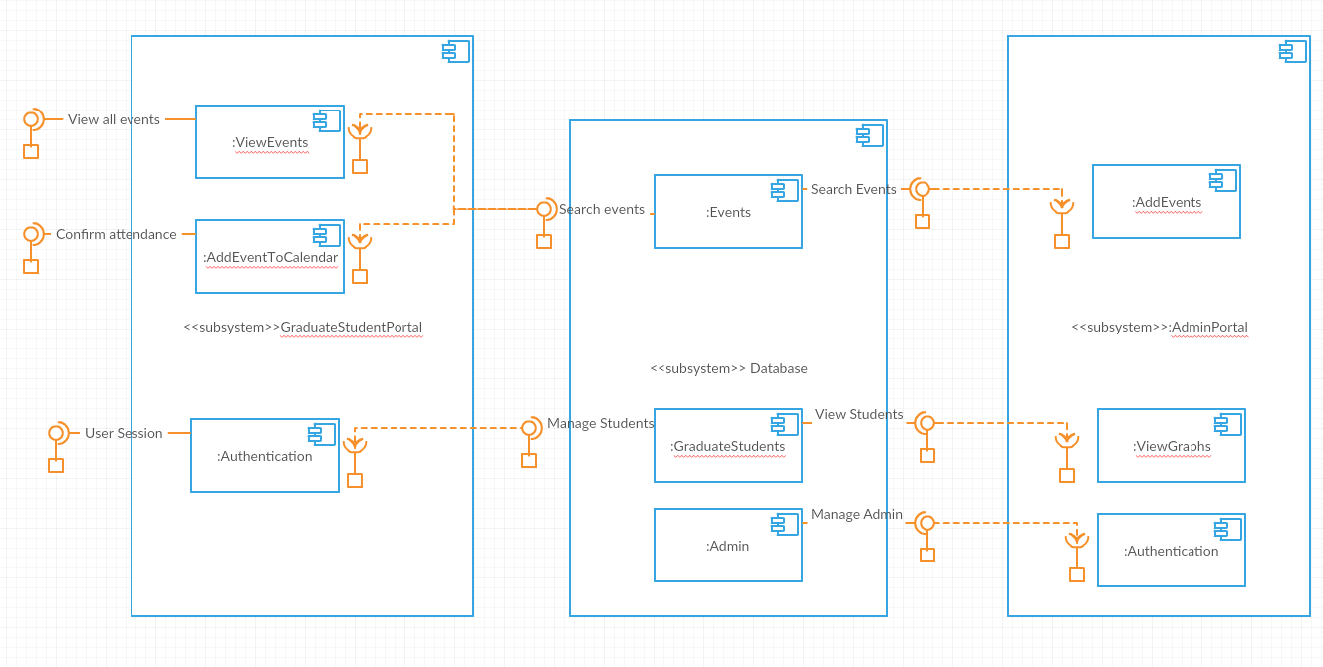

# Class Diagram

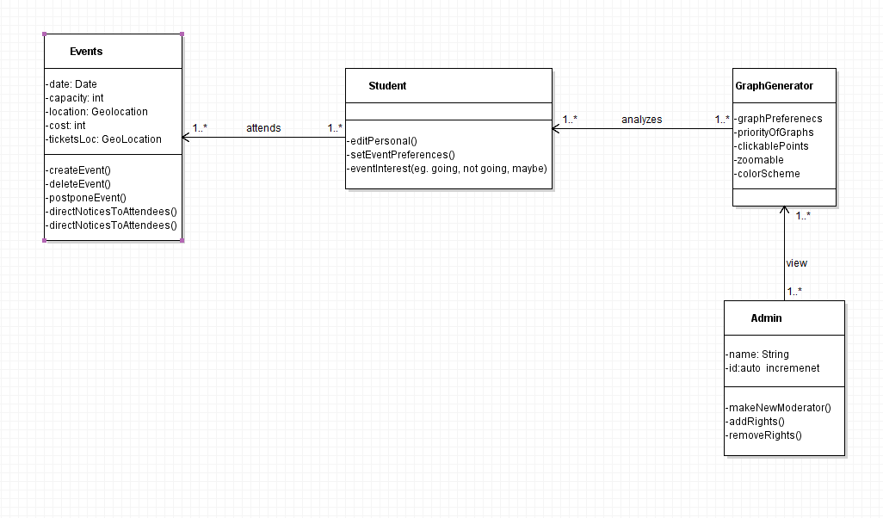

# Entity Relationship

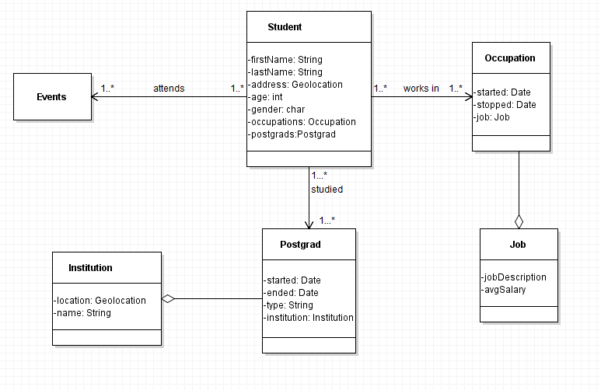

# Sequence Diagram

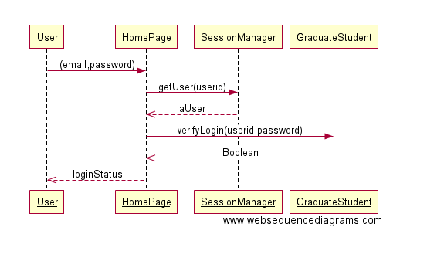

Figure 1: Login Sequence Diagram

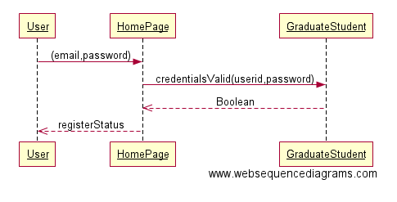

Figure 2: Register Sequence Diagram

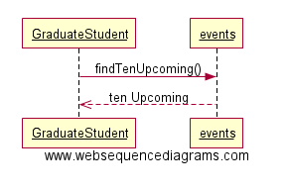

Figure 3: Ten most recent upcoming events

# Description of Technology Used

1. **MongoDB**: It is an open-source cross-platform document-oriented database program. It is also a NoSQL database program, where the JSON format of the documents define the schema. Because of its NoSQL nature, it allows for ad hoc queries to be designed, which would not be possible with a SQL nature database. This was the main reason for the choice of MongoDB as the database used.
2. **Node.js**: A JavaScript runtime environment for developing a diverse variety of server tools and applications. It allows for many of its server side modules to be written in the JavaScript language. Due to previous knowledge with JavaScript, and the support Node.js has for JSON formatted data necessary for MongoDB, it was the most appropriate choice to build the application on.
3. **Express**: Express is a web application framework that allows for several features with simple implementation that reduce the workload. Express allows for the setting of middleware’s to respond to HTTP Requests, defining a routing table which is used to perform different actions based on HTTP Method and URL, and dynamically rendering HTML Pages.
4. **Mongoose**: Mongoose is a Node.js library that provides MongoDB object mapping. It is used to query the MongoDB database from the Node.js framework.
5. **Sass**: Sass is a scripting language that is interpreted into Cascading Style Sheets (CSS). Allows for greater control over CSS than what is normally allowed.
6. **Bootstrap**: A front end framework that mainly focuses on creating a better user experience in much less time by handling most of the CSS for a general, much more appealing website.
7. **JQuery**: A JavaScript library that boasts “Write less, do more”, when compared to similar features in JavaScript.
8. **Highcharts:** The chosen JavaScript chart generator of choice. It was chosen because of its color scheme as it relates to the current theme of the website as well as the interactive nature of the charts created.
9. **Heroku**: Heroku is a platform as a service (PaaS) that enables developers to build, run, and operate applications entirely in the cloud.